GIRLS' BASKETBALL COACHES

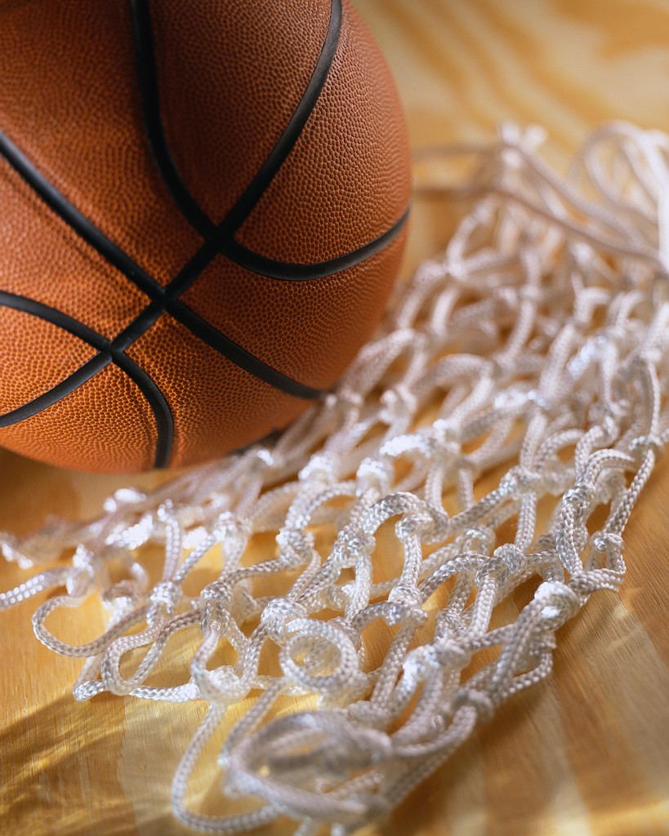

1200 w. Colton St.
Los Angeles, CA 90026
(On the corner of 1st & Beaudry Ave.)

Mandatory for all paid Girls’ Basketball Coaches to attend. If they cannot, an Athletic Director or Assistant Principal/Athletics must attend.

